NAME :- PATEL KRINA GAUTAMBHAI

ENROLLMENT NO :-2201031830014

# Steps For Creating Github Account:-

* Search Github on Google.

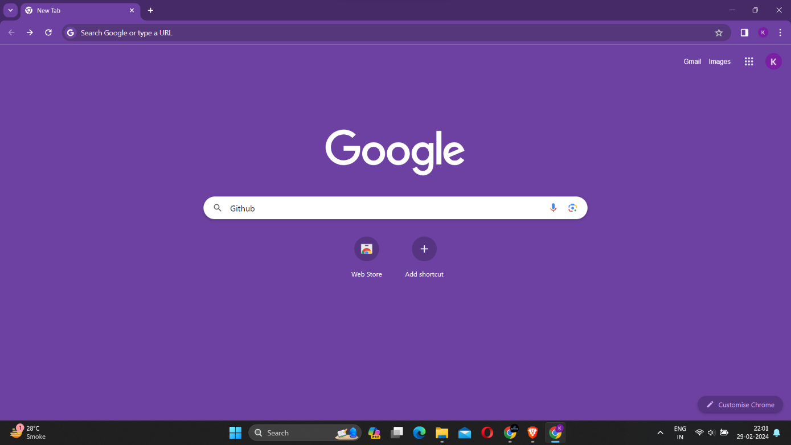

* Click on the first link.

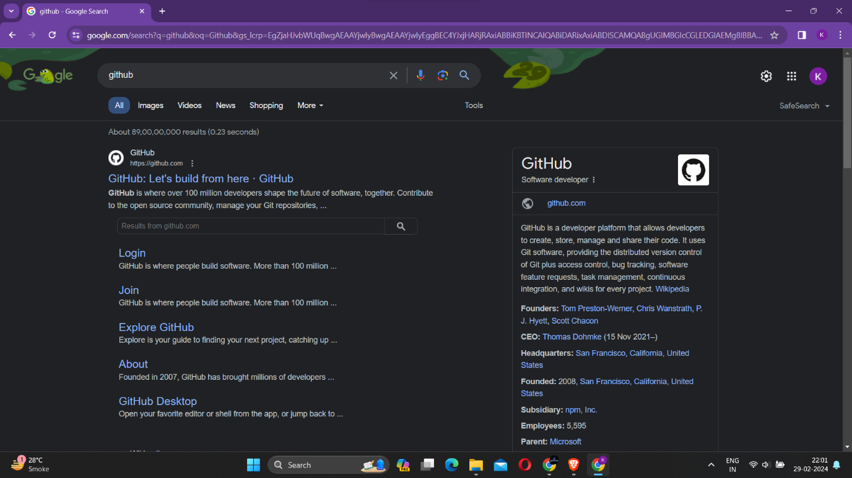

* Click on Signup



* Enter the Details such as Email, password, username.

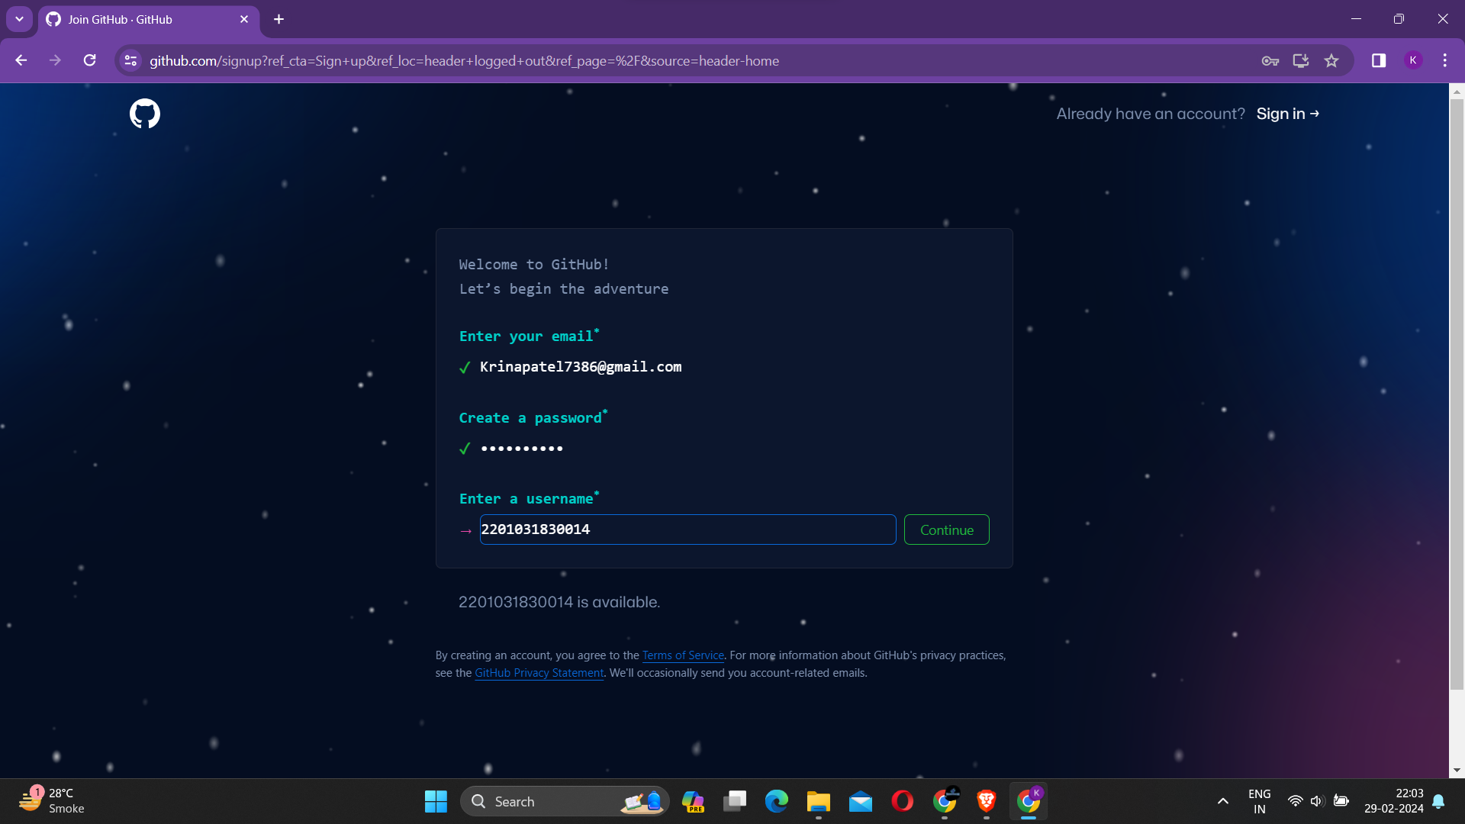

* Now after verifying click on Create Account

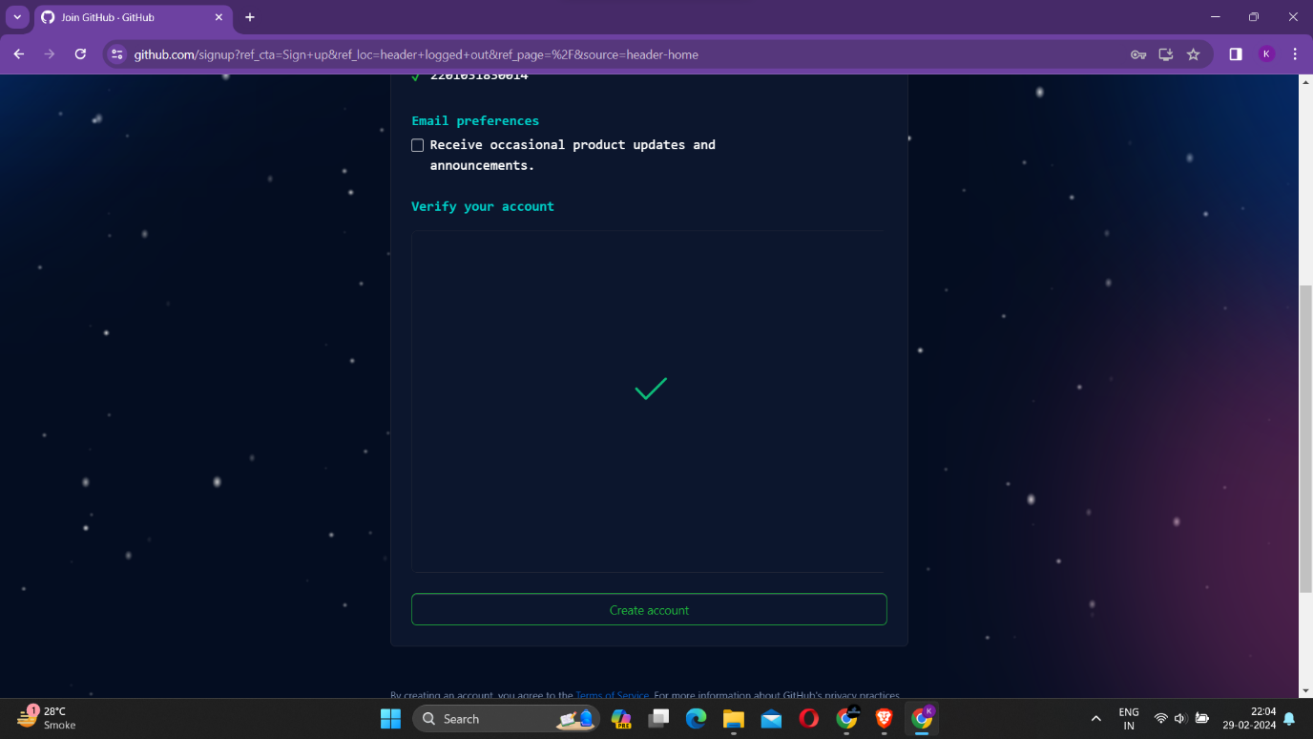

* Now Enter “Github Launch Code” which is received in email .

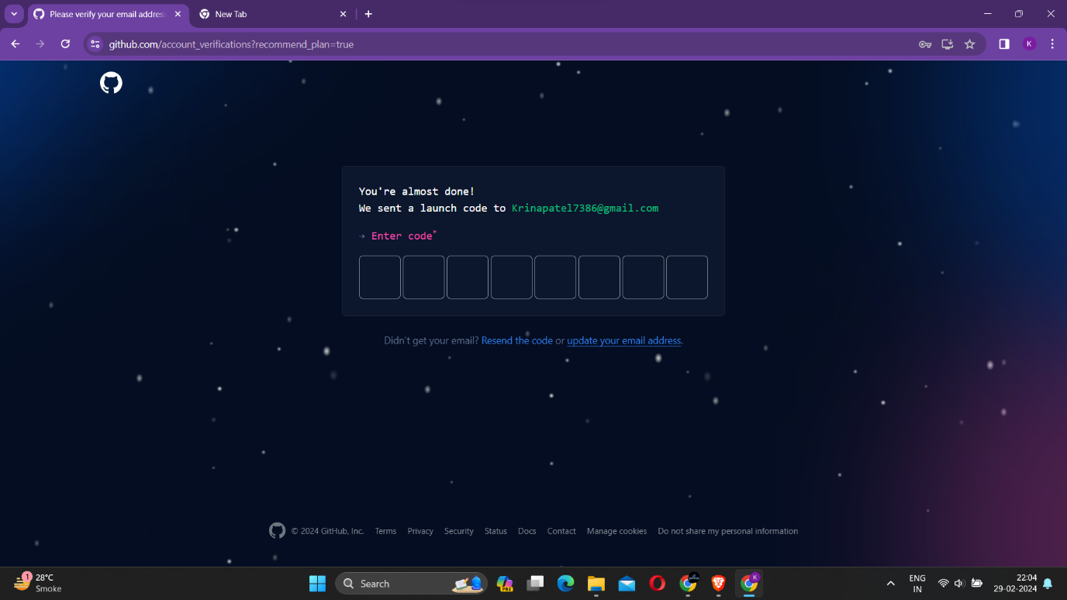

* Now Copy and enter the code in Github Verification page.

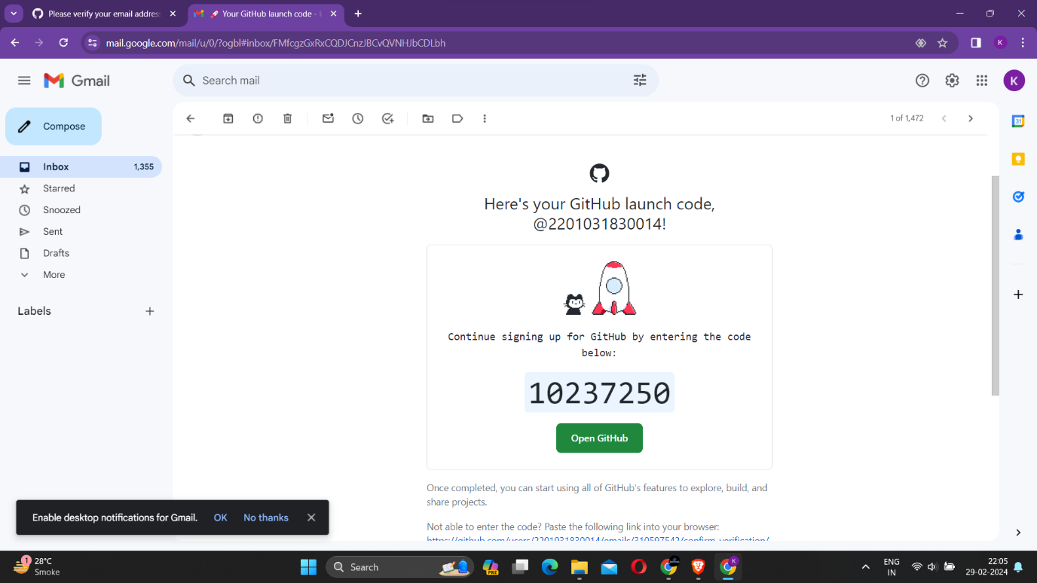

* After Verifying the code , select the features you are interested in using .

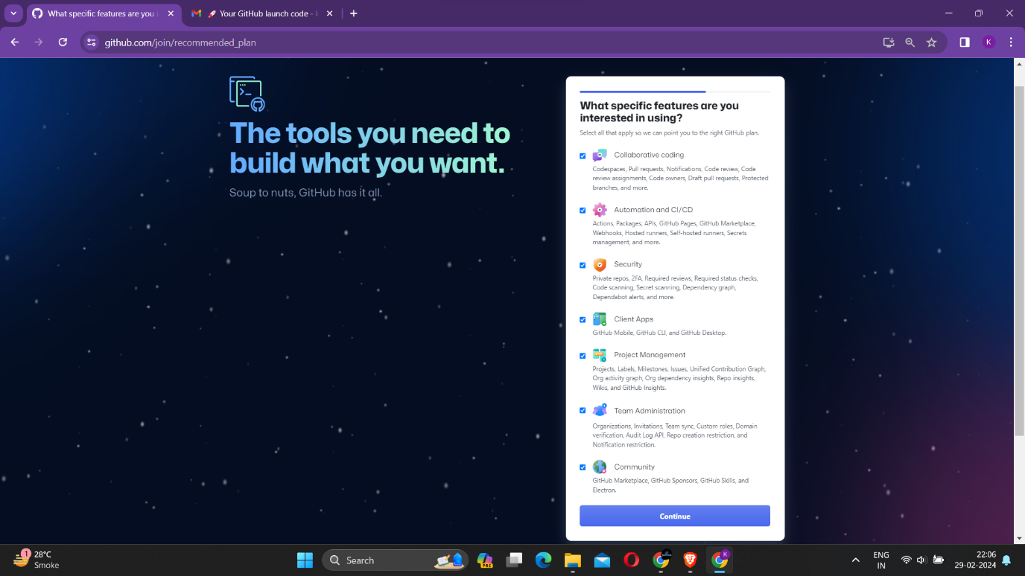

* Now select how many team members will be working with you and also select that you are a Student or a Teacher.

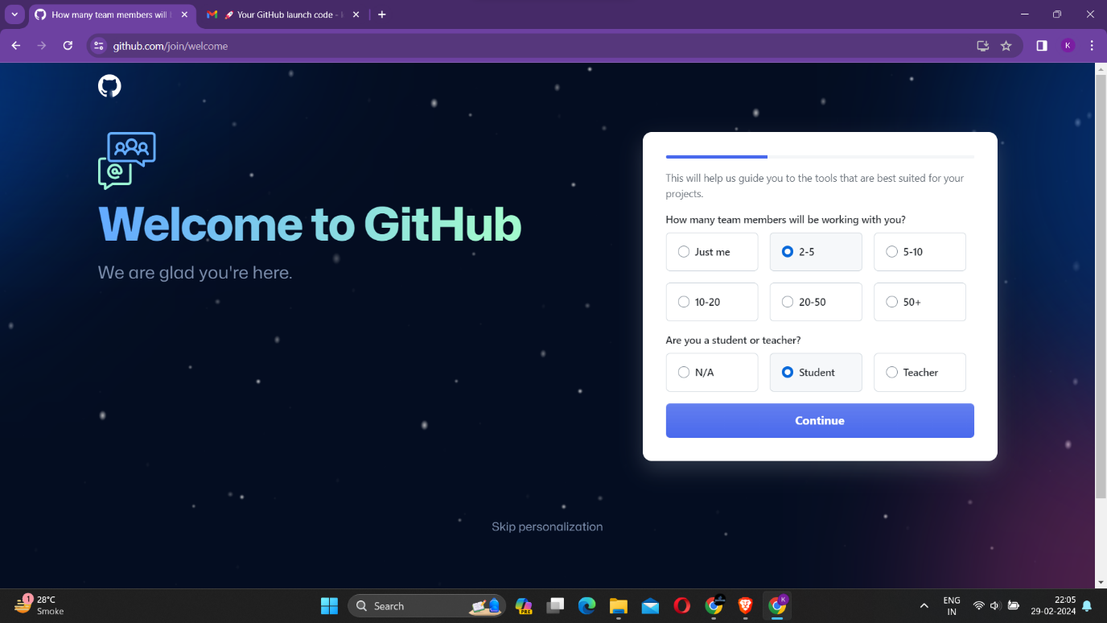

* Select the Free plan.

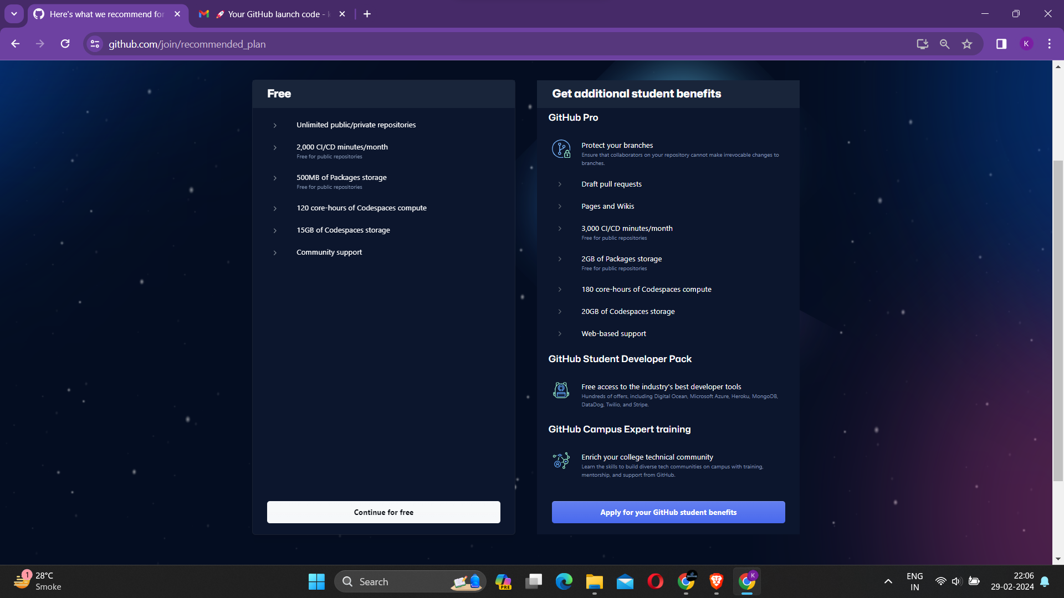

* Now you will be directed to the home page , Now click on “+” Symbol and select New Repository

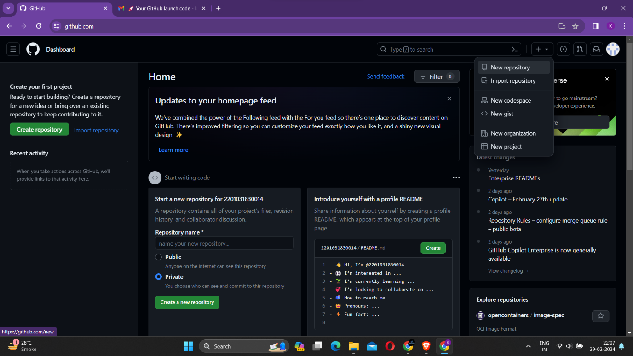

* Now Enter Repository Name”2201031830014”.
* Also set Visibility mode to Public.

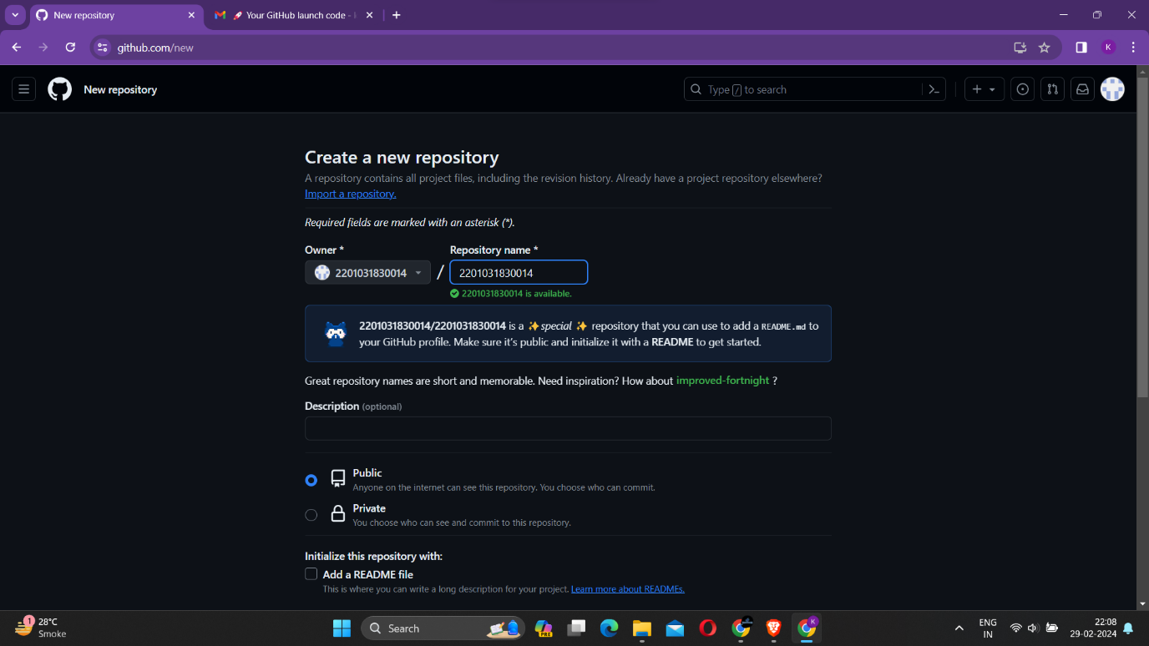

* Now Click on Create repository.

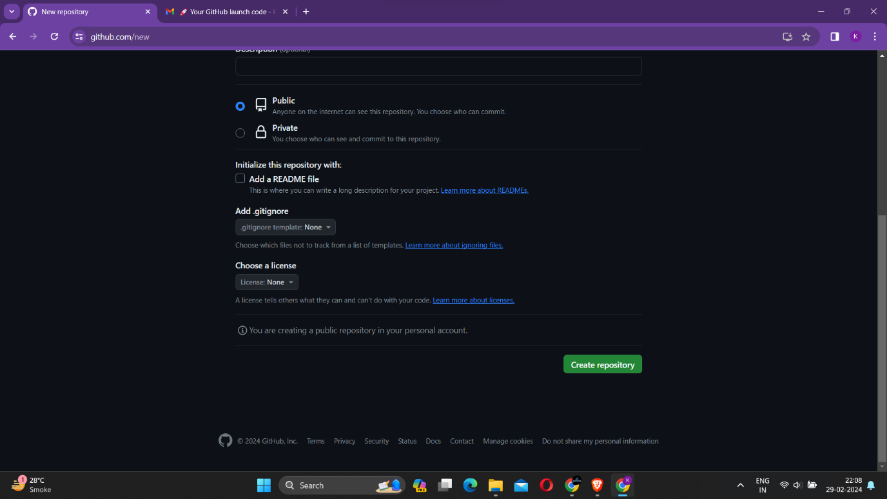

* Now After being Directed to repository page Click “Creating a new file”.

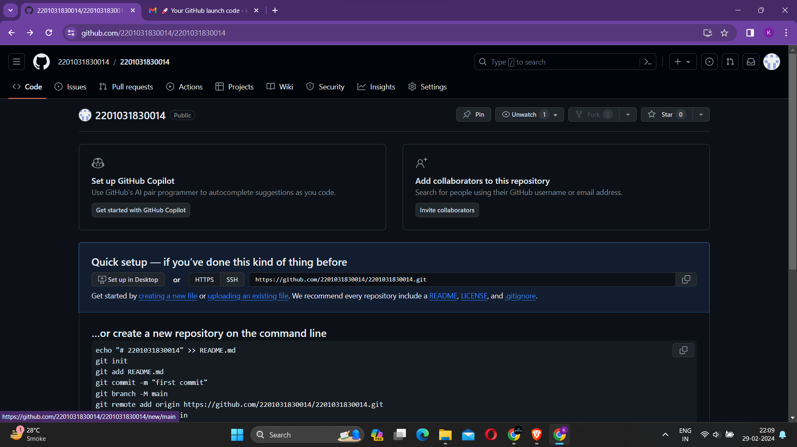

* Now to Create a folder Enter the folder name followed by a Forward slash “/ ” to create a folder.

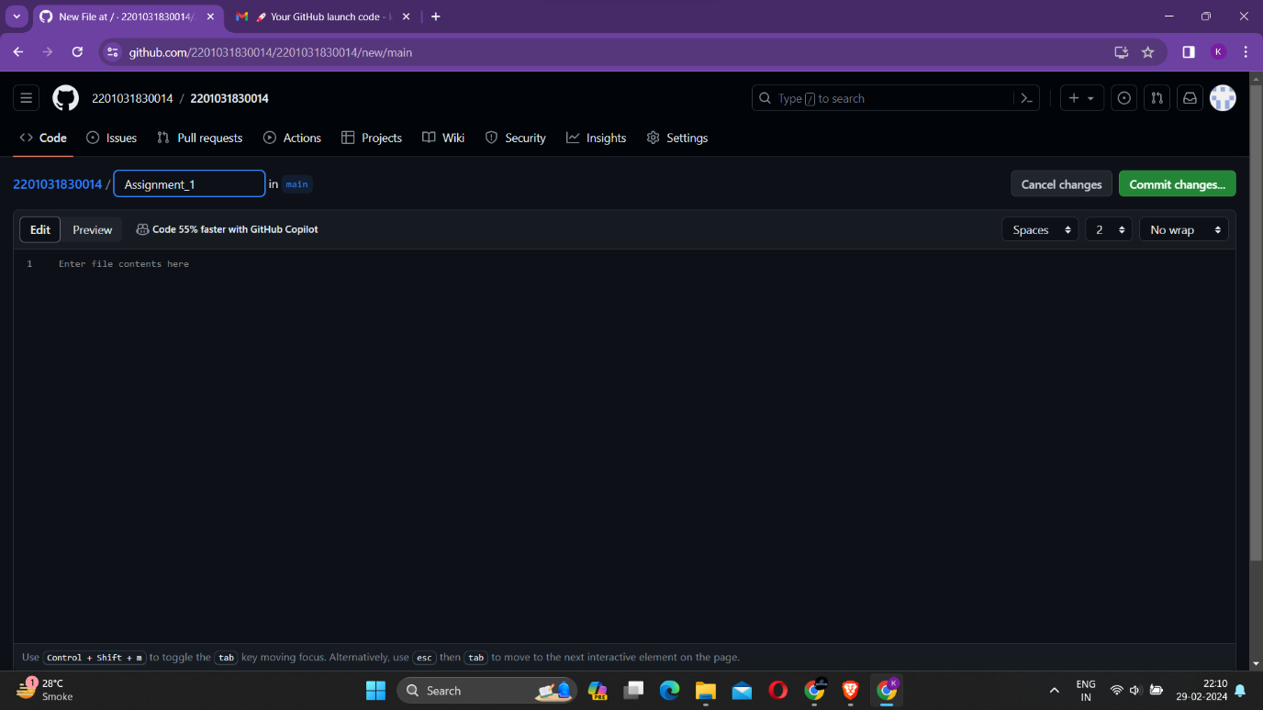

* A folder Named “Assignment_1” is created.

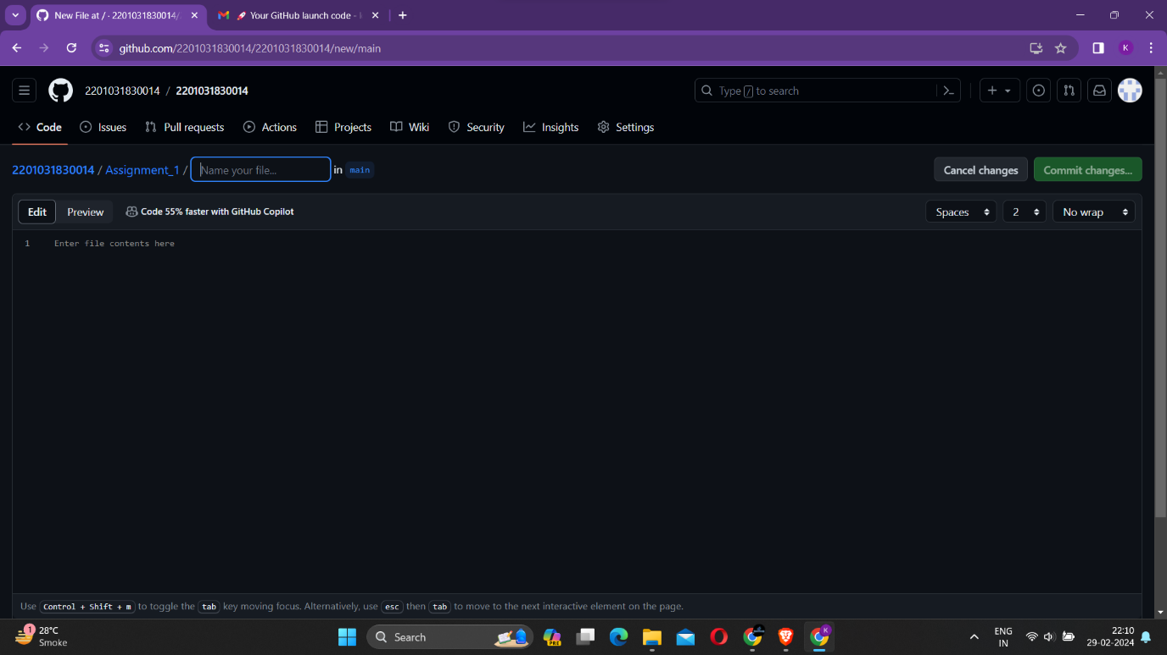

* Now enter a file name to create one. And Click on commit changes…

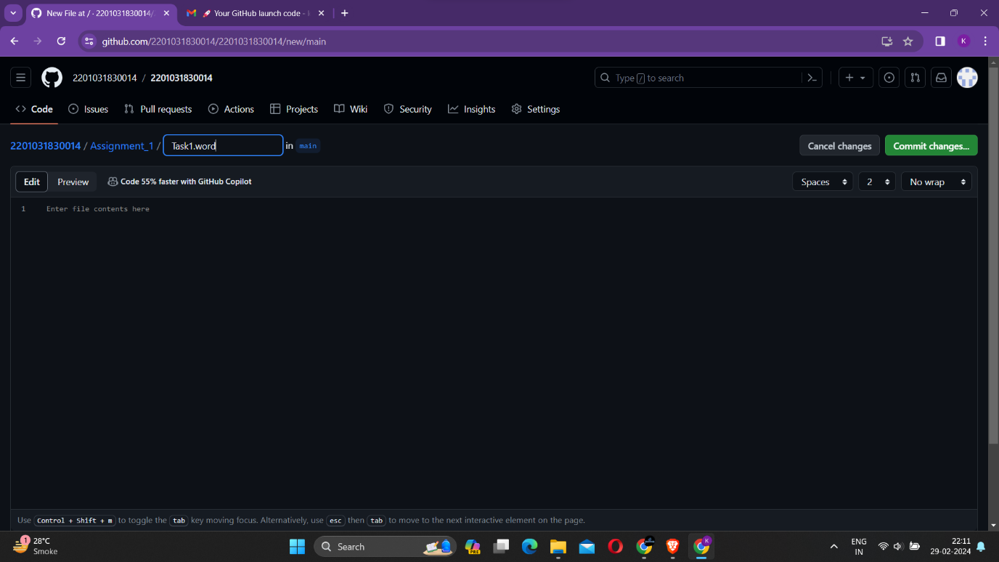

* A commit message is generated Now click on commit changes.

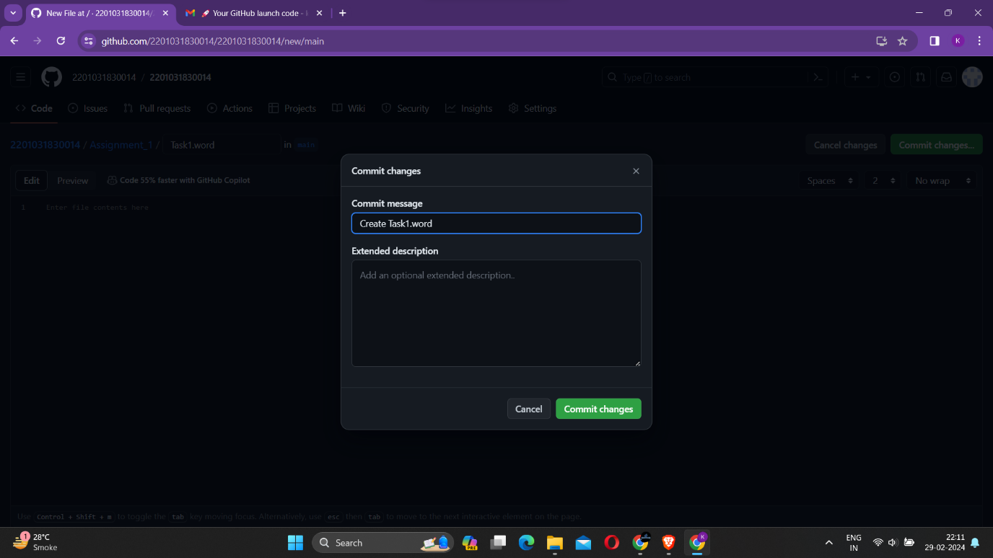

* Now we can see a file name Task1.word is created.

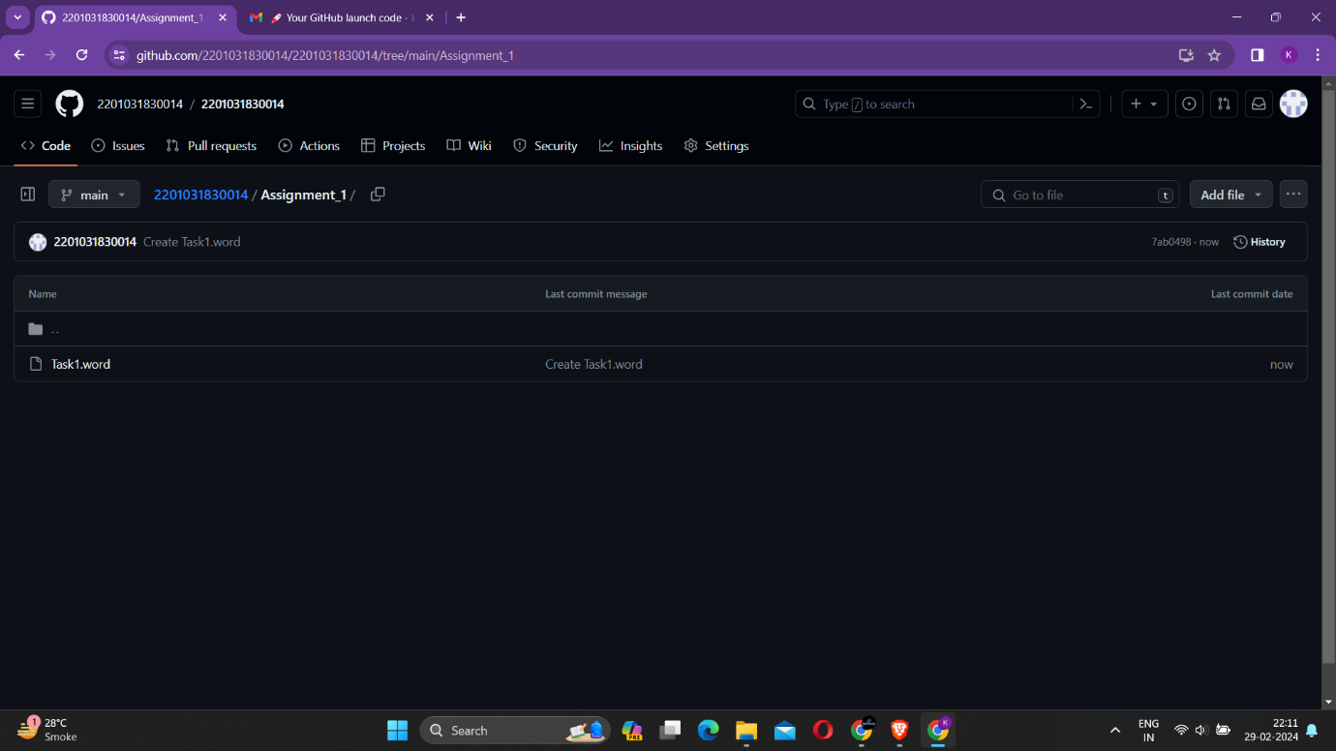

* A folder name Assignment_1 is Created.

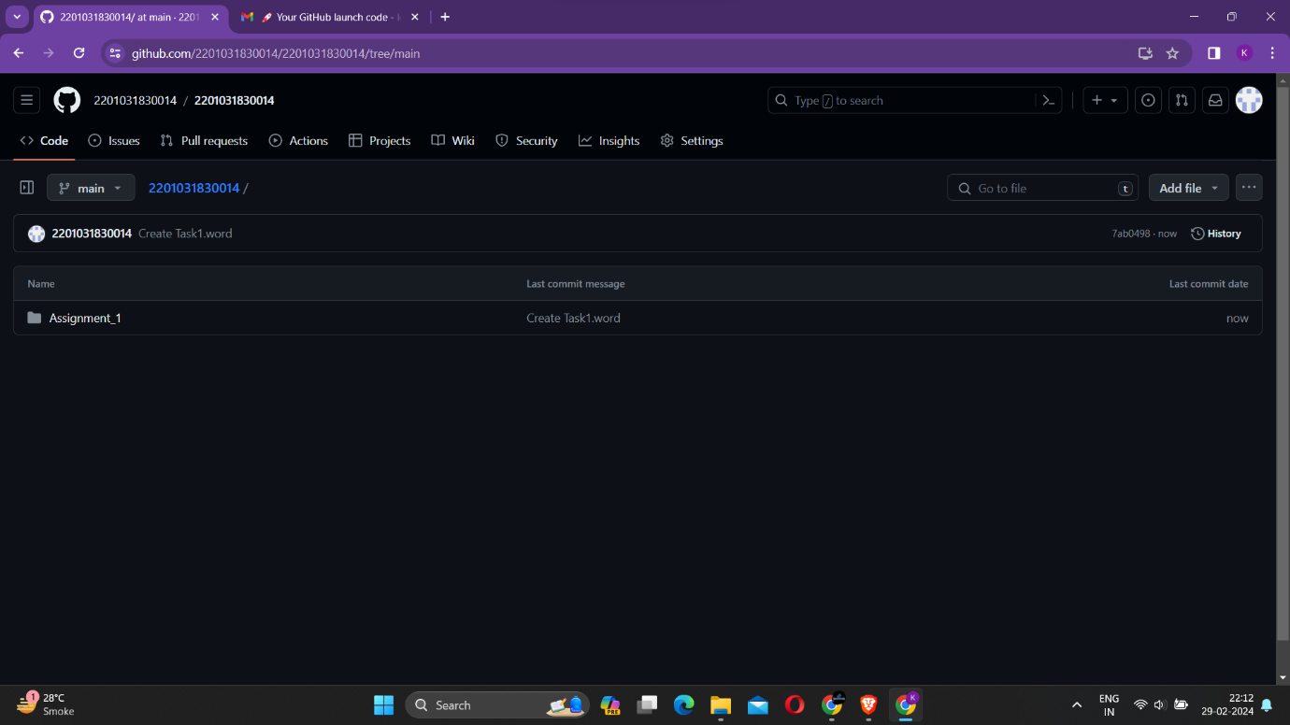

* To create Assignment_2 Folder Click on Add file and Click Create new file.

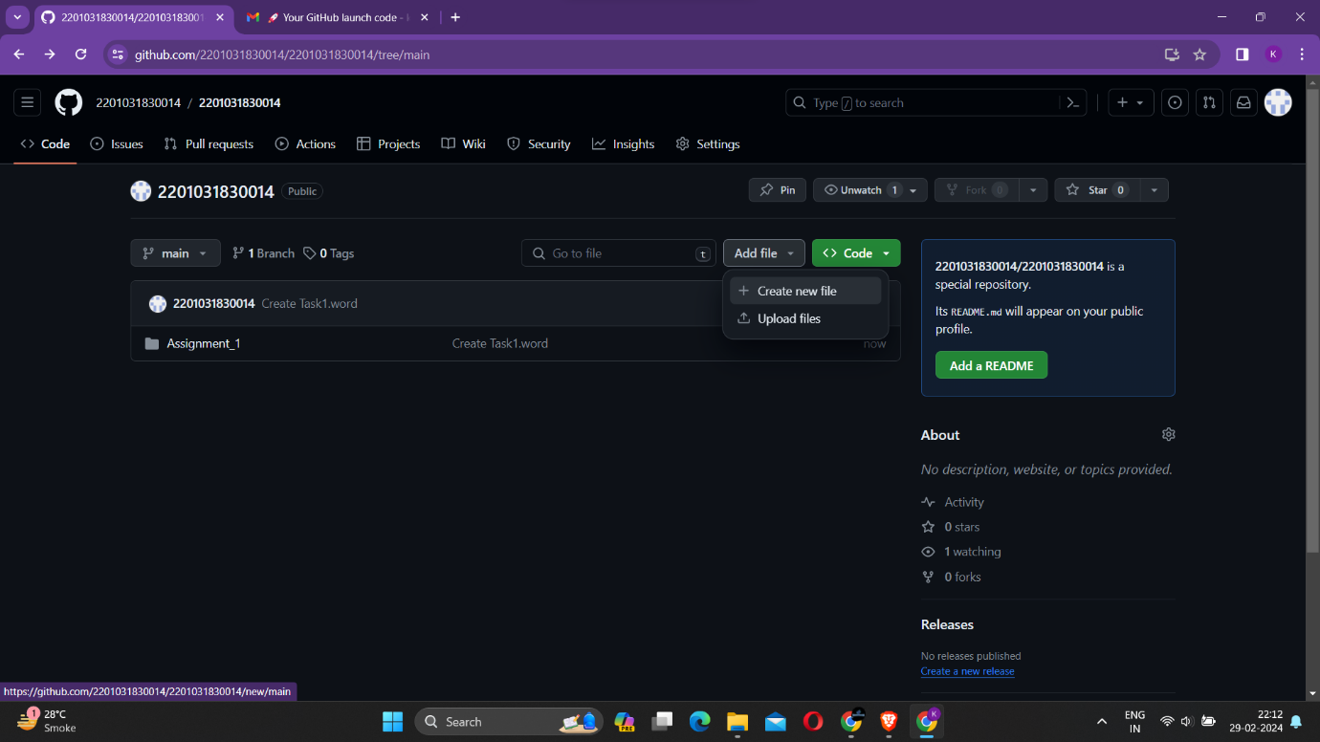

* Now type Assignment_2 followed by Forward slash “/”.

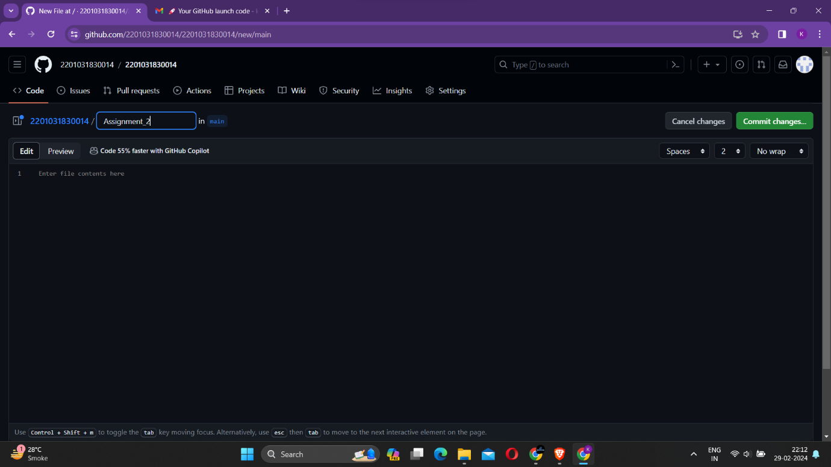

* Now create a file Name “Task1” and click on commit changes.

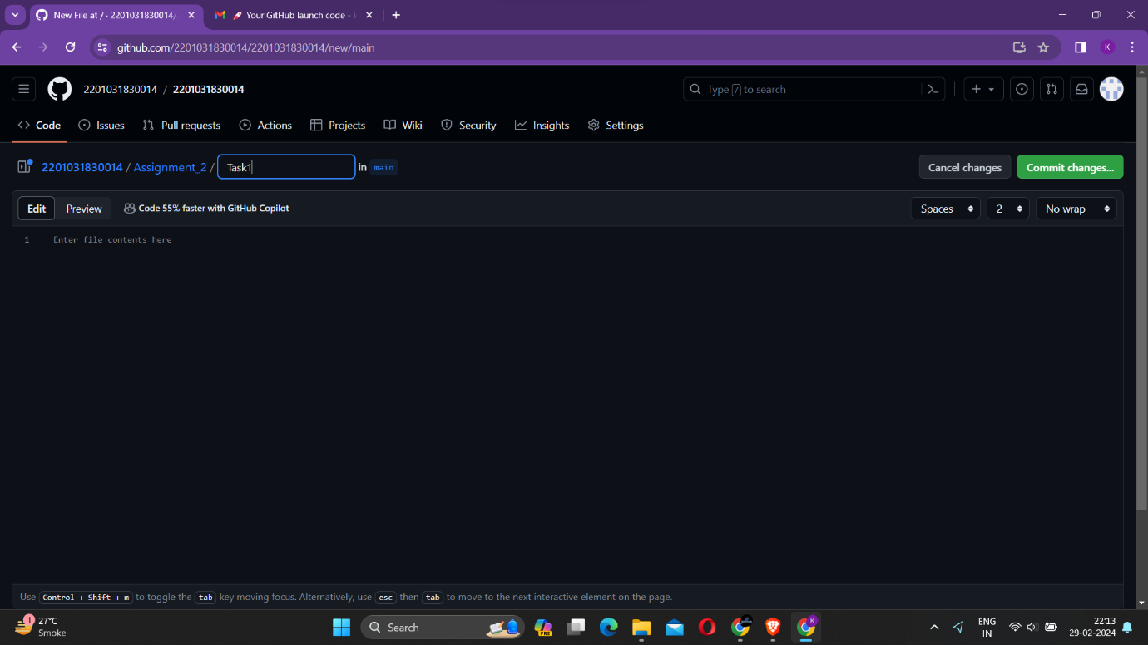

* A commit message is generated Now click on commit changes.

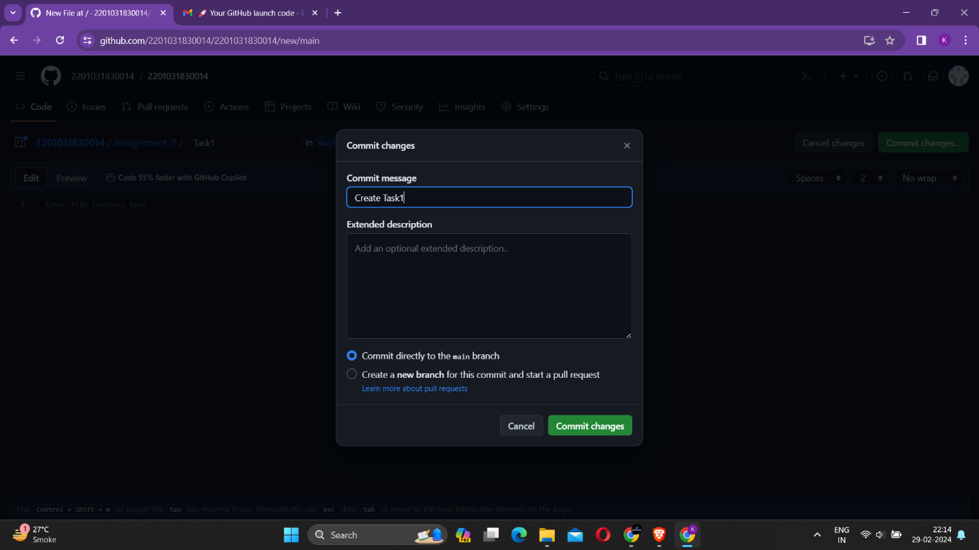

* Now we can see We have successfully created Two folders :-

1. Assignment_1
2. Assignment_2

